
ST PATRICK'S CATHOLIC PRIMARY SCHOOL
Special Educational Needs and Disabilities (SEND) Policy
2026–2027
Policy Lead: SENDCo- Miss J Edwards & Mrs S Lally
SEND Governor: Sarah Alvarez Rodrigues
Headteacher: J Lewis
Date Approved: September 2026
Review Date: September 2027
National Award for SEN Co-ordination status – SL completed award in July 2018 and JE completed award in July 2022.
Contact Details – if you require contact with either SENCo please arrange a meeting through the school office in person or via phone on 0151 709 1062 or email SENDCo@st-patricks.liverpool.sch.uk
This policy was developed in collaboration with staff and governors to promote the Inclusive practice and approach we have in our school and is available via the school office and website for parents. It is important to recognise that all our teachers are teachers of all children and we use reasonable adjustments to remove barriers to children’s learning and development so they can achieve their full potential and meet their very best outcomes. The Headteacher (Mrs Lewis) advocates and works closely with both SENCOs to ensure reasonable adjustments are made to the curriculum, teaching, learning and assessment opportunities and the accessibility of opportunity for all children including those with Special Educational Needs and/ or Disability (SEND).
Abbreviations SENCo – Special Educational Needs and Disabilities Co-ordinator.
SEND – Special Educational Needs and / or Disabilities.
This policy has been complies with Section 69 of the Children’s and families Act (2014), Regulation 51 and schedule 1 of the Special Educational Needs and Disabilities Regulations (2014) and Section 6 of the SEND Code of Practice.

Mission Statement
At St Patrick's Catholic Primary School, our mission is rooted in the Gospel values of Peace, Love and Understanding. We believe that every child is uniquely created and loved by God and deserves to be welcomed, valued and supported within our school family.
We are committed to fostering a culture of inclusion where all children feel safe, respected and able to flourish. We celebrate the individuality, strengths and talents of every pupil and recognise that diversity enriches our community. Through compassion, understanding and strong relationships, we work together to remove barriers to learning and participation so that every child can achieve their God-given potential.
Our approach to SEND reflects our belief that inclusion is everyone's responsibility. We strive to ensure that all pupils, regardless of need or disability, experience a sense of belonging, success and dignity within our school community.

Legislative Framework
This policy has been developed in accordance with:
- Children and Families Act 2014
- SEND Code of Practice: 0–25 Years (2015)
- Equality Act 2010
- Special Educational Needs and Disability Regulations 2014
- Keeping Children Safe in Education (current version)
- Working Together to Safeguard Children (current version)
- Liverpool Local Offer

Aims
At St Patrick's Catholic Primary School we aim to:
• Create an inclusive environment where every child feels welcomed, valued and understood.
• Promote the school's values of Peace, Love and Understanding in all aspects of SEND provision.
• Ensure that every pupil has equitable access to learning opportunities and experiences.
• Recognise and celebrate the strengths, interests and aspirations of pupils with SEND.
• Foster independence, confidence and resilience whilst providing appropriate support.
• Work in partnership with families, recognising parents and carers as experts on their child.
• Enable all pupils to participate fully in the academic, social, spiritual and wider life of the school.
• Develop a culture of belonging where differences are respected and celebrated.

Objectives
The school will:
- Identify and assess pupils with SEND as early as possible.
- Ensure high-quality adaptive teaching is available to all learners.
- Implement evidence-informed interventions where appropriate.
- Monitor the effectiveness of SEND provision regularly.
- Work closely with parents and carers throughout the SEND process.
- Involve pupils in setting outcomes and reviewing progress.
- Provide appropriate staff training and professional development.
- Promote equality of opportunity and eliminate discrimination.
- Ensure reasonable adjustments are made for disabled pupils.
- Support successful transitions throughout a pupil's educational journey.

Definition of SEND
A child or young person has SEND if they have a learning difficulty or disability which calls for special educational provision to be made for them.
A child has a learning difficulty or disability if they:
- Have significantly greater difficulty in learning than the majority of others of the same age; or
- Have a disability which prevents or hinders them from making use of educational facilities generally provided for others of the same age in mainstream schools.
Special educational provision means educational or training provision that is additional to or different from that made generally for other children of the same age.

Broad Areas of Need
The SEND Code of Practice identifies four broad areas of need:
Communication and Interaction
Including:
- Speech, Language and Communication Needs (SLCN)
- Autism Spectrum Condition (ASC)
Cognition and Learning
Including:
- Moderate Learning Difficulties (MLD)
- Severe Learning Difficulties (SLD)
- Profound and Multiple Learning Difficulties (PMLD)
- Specific Learning Difficulties such as Dyslexia, Dyscalculia and Dyspraxia
Social, Emotional and Mental Health (SEMH)
Including:
- ADHD
- ADD
- Attachment needs
- Anxiety
- Depression
- Trauma-related difficulties
- Emotional regulation difficulties
Sensory and/or Physical Needs
Including:
- Hearing impairment
- Visual impairment
- Multi-sensory impairment
- Physical disabilities

Identifying SEND
Early identification is essential to securing positive outcomes. We also recognise that slow progress and low attainment do not necessarily mean that a child has SEN and should not automatically lead to a pupil being recorded as having an SEN. However, the school may use this as an indicator of a range of learning difficulties or disabilities. Equally, we do not assume that attainment in line with chronological age means that there is no learning difficulty or disability for that individual child. Some learning difficulties and disabilities occur across the range of cognitive ability and, if left unaddressed, may lead to frustration and the child becoming disaffected from education, or resulting in emotional or behavioural difficulties both within school and at home. We will continually work with parents/carers to listen and hear their concerns that they may have in regards to their child’s development and progress towards outcomes. However, children can display different behaviours and feelings in different
The purpose of identification is to work out what action the school needs to take. The school identifies the needs of pupils by considering the needs of the whole child, which will include not just the special educational needs of the child or young person. Once a child has been identified as having SEN, the SENCO will ensure joint working with staff and parents to informally begin gathering evidence and start what is known as the Graduated Approach. At this point a pupil will be placed on the SEND register at SEN Support. This process will lead to the identification of the child’s primary and, if required, a secondary need. The school will not delay in putting in place extra teaching or other rigorous interventions designed to secure better progress, where required. We will also work closely with external services and Alder Hey to ensure we understand each child’s need. Where a formal diagnosis is given, we do require written confirmation from Alder Hey themselves, in order for us to fully cater for the child’s needs. Although the SENCo has overall responsibility for supporting the identification of pupils with SEND in the school, it is recognised that other members of teaching and pastoral staff have a key role to play in this process. This is part of the collective responsibility and collaborative approach of the school.
The school identifies pupils who may have SEND through:
- Teacher assessment and observation
- Progress and attainment data
- Pupil progress meetings
- Parent and carer concerns
- Pupil voice
- Information from previous settings
- Advice from external professionals
- Attendance, wellbeing and behaviour monitoring
Identification is not based solely on low attainment.
The following factors alone do not constitute SEND, although they may impact upon progress:
- English as an Additional Language (EAL)
- Attendance difficulties
- Medical needs
- Pupil Premium eligibility
- Looked After Child status
- Temporary emotional difficulties
- Poor behaviour without an underlying need
Careful assessment is undertaken to determine whether SEND provision is required.

The Graduated Approach
At St Patrick's Catholic Primary School, we follow the graduated approach outlined in the SEND Code of Practice (2015). This process ensures that support is carefully planned, implemented and reviewed to meet individual needs.
First and foremost, we ensure high quality teaching for all children throughout the school which is personalised to their needs. We ensure all children can access the curriculum and strive to maintain high standards of teaching and learning. To support children, we have a differentiated and personalised approach for individual pupils, this is the first step in responding to pupils to have or may have SEN. This high-quality teaching is essential to the success of pupils and additional intervention and support cannot compensate for a lack of high quality teaching. Teaching and Learning throughout the school is monitored across a range of subjects by both Senior Leadership Team and subject leaders. This informs professional development plans to ensure all staff receive the training and support they require for the benefit of all children.
We offer a tailored intervention programme to meet the needs of children within our school. Children can access a wide variety of these interventions, which are delivered by staff who have received training. It is the class teachers who are ultimately responsible and accountable for the children’s progress, attainment and development of all the pupils within their class, including where pupils access support from teaching assistants or specialist staff. For children who have a higher level of need, we follow the Local Authorities procedures. We seek advice and guidance from external specialists which we can then implement in school and support families implementing at home. If difficulties are still not addressed we may apply to the local authority for Top Up Funding to assist us in providing further support. In some cases, were the level of need is much higher, we can apply to the local authority to carry out an assessment for an Educational Health Care plan.
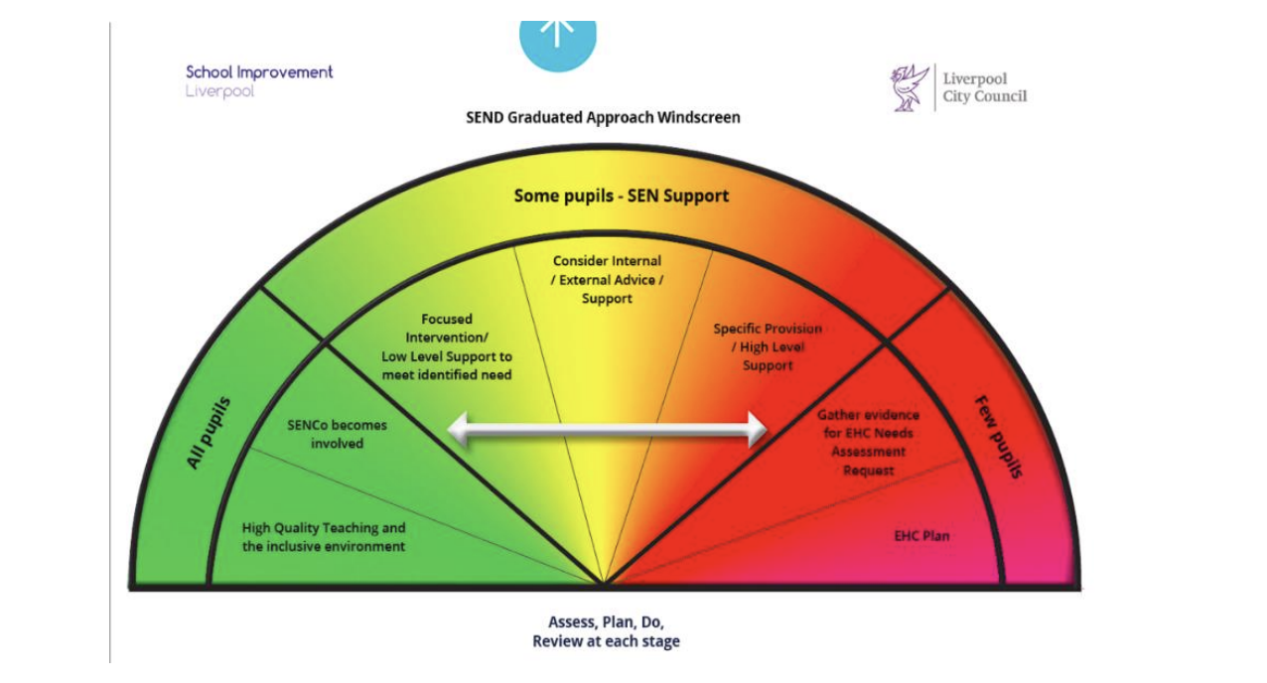
Assess
A thorough assessment of a pupil's strengths and needs is undertaken using:
- Teacher assessment and observation
- Attainment and progress data
- Parent and pupil views
- Information from previous settings
- Advice from external professionals where appropriate
- Attendance, wellbeing and behaviour information
Assessment is ongoing and forms the basis for planning appropriate support.
Plan
Where SEND is identified, outcomes are agreed collaboratively with parents, pupils and staff. Provision is planned to address identified barriers to learning.
Plans may include:
- Adaptive teaching strategies
- Additional interventions
- Reasonable adjustments
- Environmental adaptations
- Specialist resources
- External agency involvement
Do
The class teacher remains responsible for the progress and attainment of all pupils in their class, including those receiving SEND support.
Support may be delivered through:
- High-quality adaptive teaching
- Small group interventions
- Individual support
- Specialist programmes
- Advice from external professionals
Review
Progress towards agreed outcomes is reviewed regularly with parents, pupils and staff.
Reviews consider:
- Progress made
- Effectiveness of support
- Pupil and parent views
- Any changes in need
- Next steps
Provision is adjusted accordingly.

SEND Support
Where a pupil requires provision that is additional to or different from that ordinarily available, they may be placed on the SEND Register at SEND Support.
Provision may include:
- Adaptive classroom strategies
- Targeted interventions
- Communication support
- Social and emotional support
- Sensory accommodations
- Specialist equipment
Placement on the SEND Register is made in consultation with parents and reviewed regularly.

Supporting pupils and families throughout the graduated approach to SEND At St Patrick’s Catholic Primary School, we recognise that the impact of SEND support can be strengthened by increasing parental engagement in the approaches and teaching strategies that are being used. We also value and welcome the essential information on the impact of SEND support outside school as well as the parents/carers particular knowledge of their child/young person and any changes in needs which they can provide. The school operates an open-door policy where parents are encouraged to communicate openly with the school in a timely way should they have any concerns regarding their child/young person.
Where a pupil is receiving SEND Support the school endeavours to talk to parents/carers regularly to set clear outcomes and review progress towards them, discussing the activities and support that will help achieve them and identify the responsibilities of the parent, the pupil and the school. At all stages of the SEND process the school keeps parents/carers fully informed and involved. Regular meetings are scheduled throughout the academic year to share the progress of the pupils with parents/carers and to take account of their views. It is hoped that this will assist in supporting pupils to reach their full potential. Parents/carers are encouraged to make a full and active contribution to their child’s education.
At St Patrick’s Catholic Primary School, we recognise our duties regarding equality and inclusion for individual disabled children and young people under the Equality Act 2010. We make reasonable adjustments, including the provision of auxiliary aids and services for children to prevent them being put at significant disadvantage. We also recognise that these are anticipatory duties and strive to make arrangements in advance to prevent disadvantage. It is important to foster good relations and promote equality of opportunity generally so that barriers to learning are removed. Children/young people are encouraged to participate fully in the life of the school which includes extracurricular clubs, activities and extended visits. We do require advice and recommendations from many specialists, including those at Alder Hey, to help us best meet the needs of children.
Education, Health and Care Plans (EHCPs)
For a small number of pupils whose needs are significant and complex, an Education, Health and Care Needs Assessment may be requested from the Local Authority.
An EHCP may be considered when:
- A pupil continues to make limited progress despite sustained and targeted support.
- Significant additional provision is required.
- Multi-agency involvement indicates long-term and complex needs.
EHCPs are reviewed annually in partnership with parents, pupils, school staff, the Local Authority and relevant professionals.

Working in Partnership with Parents and Carers
We recognise that parents and carers know their children best and are essential partners in the SEND process.
We will:
- Listen to parental views and concerns.
- Involve parents in decision-making.
- Share information openly and honestly.
- Provide opportunities for regular review meetings.
- Signpost families to relevant support services.
Parents are encouraged to contact the SENDCo whenever concerns arise.

Pupil Voice and Participation
Pupils are encouraged to participate in decisions about their learning and support.
Where appropriate, pupils will:
- Share their views about school.
- Contribute to target setting.
- Attend review meetings.
- Discuss what helps them learn successfully.
- Share aspirations and future goals.
We believe that involving pupils promotes independence, confidence and self-advocacy.

Inclusion and Accessibility
Inclusion is at the heart of everything we do at St Patrick's Catholic Primary School. We believe that every child has a right to belong, participate and succeed within our school community.
We recognise that some children may face barriers to learning, communication, social interaction or emotional wellbeing. Through our values of Peace, Love and Understanding, we seek to understand each child's individual needs and respond with empathy, compassion and high expectations.
We are committed to creating a school culture where children learn to respect and value differences, show kindness towards one another and celebrate the unique gifts that every individual brings to our community. Pupils with SEND are encouraged and supported to participate fully in all aspects of school life, including worship, leadership opportunities, educational visits, clubs and wider enrichment activities.
Our aim is not simply inclusion within school, but a genuine sense of belonging where every child feels known, understood and valued.
Reasonable adjustments may include:
- Adapted teaching approaches
- Accessible learning materials
- Specialist equipment
- Environmental adaptations
- Additional adult support where appropriate
Pupils with SEND are encouraged and supported to participate fully in:
- Educational visits
- Extra-curricular activities
- Sporting events
- School performances
- Leadership opportunities
The school's Accessibility Plan details how accessibility is continually improved.

Supporting Social, Emotional and Mental Health
We recognise that positive emotional wellbeing underpins successful learning.
Our approach is based on strong relationships, nurture and inclusion.
Support may include:
- Emotional literacy programmes
- Nurture provision
- Access to therapeutic support
- Pastoral interventions
- Mental Health Support Team involvement
- Early Help support
- Referral to specialist services where required
We aim to create an environment where pupils feel safe, valued and understood.

Roles and Responsibilities
Governing Body
The Governing Body is responsible for ensuring that:
- SEND legislation is implemented effectively.
- Appropriate provision is made for pupils with SEND.
- Resources are allocated appropriately.
- The effectiveness of SEND provision is monitored.
Headteacher
The Headteacher is responsible for:
- The strategic leadership of SEND.
- Ensuring inclusion remains a whole-school priority.
- Supporting the SENDCo.
- Ensuring staff receive appropriate training.
SENDCo
The SENDCo will:
- Oversee the day-to-day operation of SEND provision.
- Coordinate support for pupils with SEND.
- Maintain the SEND Register.
- Liaise with parents and external agencies.
- Support staff in meeting pupils' needs.
- Monitor the impact of provision.
- Ensure statutory requirements are met.
Class Teachers
Class teachers are responsible for:
- The progress and attainment of all pupils in their class.
- Delivering high-quality adaptive teaching.
- Identifying emerging needs.
- Implementing agreed provision.
- Working collaboratively with parents and the SENDCo.

Staff Training and Professional Development
At St Patrick's Catholic Primary School, we recognise that the quality of provision for pupils with SEND is directly linked to the knowledge, confidence and expertise of our staff. We are committed to fostering a culture of continuous professional development where all staff are encouraged to reflect, learn and grow in their practice.
Through training, collaboration and professional dialogue, we strive to ensure that every member of staff understands their responsibility in creating an inclusive learning environment rooted in our values of Peace, Love and Understanding. Staff are supported to develop their knowledge of a wide range of needs and to implement evidence-informed strategies that enable every child to flourish.
We value the wealth of experience within our school community and encourage staff to share good practice, learn from one another and work collaboratively with families and external professionals. Professional development is viewed not simply as training, but as an ongoing commitment to ensuring that every child receives the understanding, support and opportunities they need to achieve their full potential.
Professional development may include:
- Whole-school training
- SENDCo briefings
- External specialist training
- Coaching and mentoring
- Professional reading and research
Training is identified through school priorities and pupil needs.

SEND Funding
At St Patrick's Catholic Primary School, we believe that funding should be used thoughtfully and compassionately to ensure that every child receives the support they need to thrive. Our decisions are guided by our commitment to inclusion and our values of Peace, Love and Understanding, ensuring that resources are directed where they will have the greatest impact on children's learning, wellbeing and independence.
We carefully consider the individual needs of our pupils and use SEND funding to provide additional staffing, specialist resources, targeted interventions, professional development and access to external expertise. We recognise that every child is different, and therefore provision is tailored to meet individual strengths and needs rather than adopting a one-size-fits-all approach.
Funding is used not only to support academic progress, but also to promote confidence, communication, emotional wellbeing and a sense of belonging within our school community. Through careful monitoring and evaluation, we ensure that resources are used effectively so that every child is given the opportunity to flourish, participate fully in school life and achieve their potential.

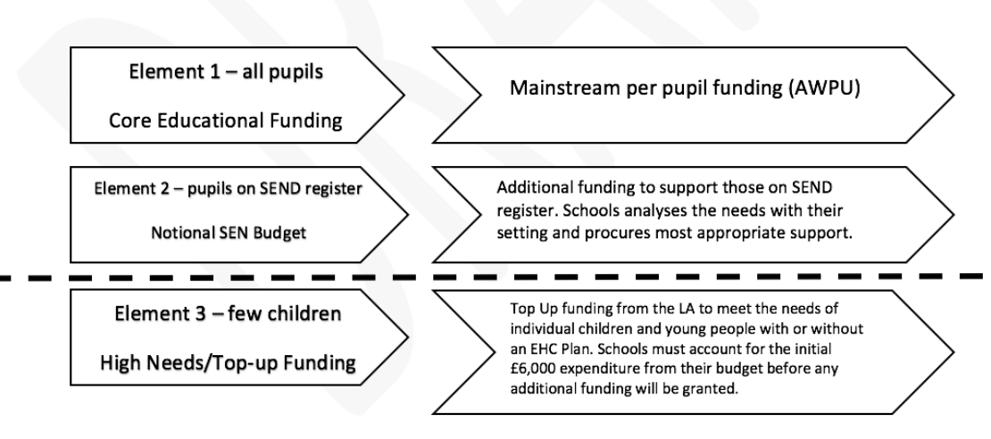
The school uses its delegated SEND funding to support pupils effectively.
Funding may be used for:
- Additional staffing
- Intervention programmes
- Specialist resources
- Training and professional development
- Specialist assessments
- Assistive technology
- Environmental adaptations
The impact of spending is reviewed regularly to ensure value and effectiveness.

Monitoring and Evaluation
At St Patrick's Catholic Primary School, monitoring and evaluation are not simply about measuring progress; they are about ensuring that every child feels valued, supported and able to flourish within our school community. Guided by our values of Peace, Love and Understanding, we continually reflect on the effectiveness of our provision to ensure that it meets the changing needs of our pupils and enables them to achieve their full potential.
We work closely with children, families, staff and external professionals to understand what is working well and where improvements can be made. Through regular reviews, pupil voice, parental feedback, observations and assessment information, we celebrate successes and identify the next steps needed to support each child's learning, wellbeing and personal development.
We recognise that progress looks different for every child. Therefore, when evaluating provision, we consider not only academic outcomes but also confidence, independence, communication skills, emotional wellbeing, participation and sense of belonging. By listening carefully to our pupils and their families and working collaboratively as a school community, we strive to ensure that every child experiences success and knows that they are an important and valued member of St Patrick's Catholic Primary School.
The effectiveness of SEND provision is monitored through:
- Pupil progress and attainment data
- Provision reviews
- Learning walks
- Pupil voice
- Parent feedback
- SEND reviews
- Governor monitoring
The school seeks continuous improvement in outcomes for pupils with SEND.

Complaints
If parents or carers have concerns regarding SEND provision, they should initially speak with the class teacher or SENDCo.
If concerns remain unresolved, the school's Complaints Policy should be followed.
The Local Authority SEND Information, Advice and Support Service (SENDIASS) can also provide impartial advice and guidance.

Linked Policies
This policy should be read alongside:
- SEND Information Report
- Accessibility Plan
- Equality Policy
- Safeguarding and Child Protection Policy
- Behaviour Policy
- Attendance Policy
- Medical Needs Policy
- Mental Health and Wellbeing Policy
- Admissions Policy
Policy Review
This policy will be reviewed annually by the SENDCo, Headteacher and Governing Body to ensure continued compliance with statutory requirements and best practice.
Date Approved: September 2026
Review Date: September 2027

