Starting school or nursery

Useful websites
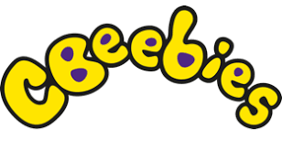
https://www.bbc.co.uk/cbeebies/curations/starting-school-curation
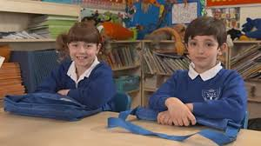
Lots of different sections, clips and tips to do with starting
school, featuring cbeebies presenters and characters.

These two sections may be especially useful:
https://www.bbc.co.uk/cbeebies/grownups/starting-school-experiences
https://www.bbc.co.uk/cbeebies/joinin/independence-skills-for-starting-school
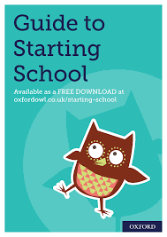
https://www.oxfordowl.co.uk/for-home/starting-school/
Some good activities, tips, ideas and book recommendations,
but please don’t feel you have to buy all the books!

https://literacytrust.org.uk/family-zone/
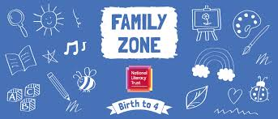
Some really lovely online books and activities linked to them. Also a guide to apps and other useful websites. A really good website, with ideas for children of all ages.

https://www.bbc.co.uk/tiny-happy-people
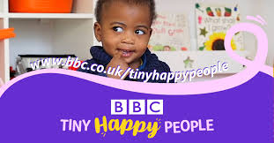
Another lovely website with all sorts of useful ideas and
resources for under-fives.

Especially useful:

https://www.bbc.co.uk/tiny-happy-people/4-to-5-year-old-child-development-activities
https://www.bbc.co.uk/tiny-happy-people/3-to-4-year-old-child-development-activities

https://www.pacey.org.uk/working-in-childcare/spotlight-on/being-school-ready/#readyforschool Links to advice on helping your child prepare for school.

Some animated stories to support emotional well-being:

The Colour Monster: https://www.youtube.com/watch?v=PWujGPb6mgo

What do you do with a problem? https://youtu.be/UrElYjbllTk

How to Catch a Star: https://youtu.be/rDMnOx7w6OA

Starting school or nursery

Useful books

Jellybean goes to school – by Margaret Roc and Laura Hughes

Biff, Chip and Kipper: starting school – by Roderick Hunt and Alex Brychta
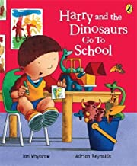

Harry and the dinosaurs go to school
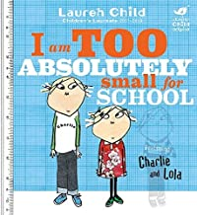
– by Ian Whybrow and Adrian Reynolds

I am too absolutely small for school (Charlie and Lola)
– by Lauren Child

Topsy and Tim start school – by Jean and Gareth Adamson

Come to school too, Blue kangaroo! – by Emma Chichester-Clark

Usborne first experiences: Going to school – by Anna Civardi and Stephen Cartwright

Max and Millie start school (Usborne) – by Felicity Brooks and Desideria Guicciardini

Never take a bear to school – by Mark Sperring and Britta Teckentrup
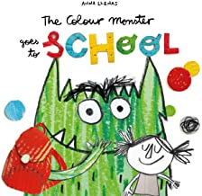
The colour monster goes to school – by Anna Llenas

The Koala who could – by Rachel Bright
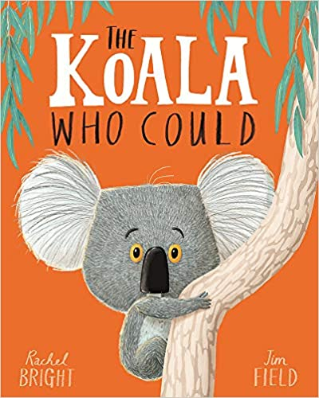
(This lovely book is about dealing with worry and change)

