Starting school or nursery

Useful websites
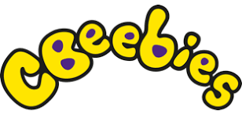
https://www.bbc.co.uk/cbeebies/curations/starting-school-curation
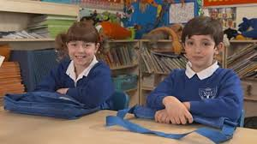
Lots of different sections, clips and tips to do with starting
school, featuring cbeebies presenters and characters.

These two sections may be especially useful:
https://www.bbc.co.uk/cbeebies/grownups/starting-school-experiences
https://www.bbc.co.uk/cbeebies/joinin/independence-skills-for-starting-school
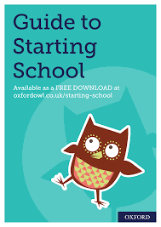

https://www.oxfordowl.co.uk/for-home/starting-school/
Some good activities, tips, ideas and book recommendations,
but please don’t feel you have to buy all the books!

https://www.foundationyears.org.uk/files/2015/03/4Children_ParentsGuide_2015_WEB.pdf This is a guide for parents on supporting your child’s development, rather than being specifically to do with starting nursery / school, but has lots of really good information and ideas.
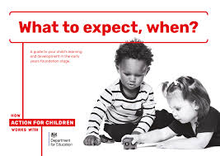

https://literacytrust.org.uk/family-zone/
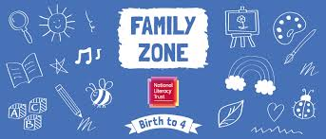
Some really lovely online books and activities linked to them. Also a guide to apps and other useful websites. A REALLY good website, with ideas for children of all ages.

https://www.bbc.co.uk/tiny-happy-people
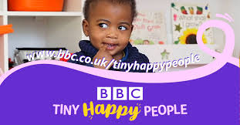
Another lovely website with all sorts of useful ideas and
resources for under-fives.

Especially useful:

https://www.bbc.co.uk/tiny-happy-people/4-to-5-year-old-child-development-activities
https://www.bbc.co.uk/tiny-happy-people/nursery-rhymes-and-songs-collection

https://hungrylittleminds.campaign.gov.uk
Lots of really practical and easy activity ideas for under-fives, plus advice on apps etc.

https://ican.org.uk/i-cans-talking-point/parents/parent-faqs/
Fact sheets focusing on different aspects of supporting children’s communication.
Starting school or nursery

Useful books

Keep an eye on the school twitter as we will be reading some of these out online and will post links! @st_patricks

They will be added to other online storytelling posts at:

https://www.youtube.com/channel/UCLhTjjD9_Pjx3kl-Y2iu3hg Miss O’Callaghan reading
https://www.youtube.com/channel/UCNLf5qju3USUEdtz6NRIjKw Mrs Potts reading
https://www.youtube.com/channel/UCEHySxJpuKeh3_3mEvMpRLg Mrs Davies reading

Jellybean goes to school – by Margaret Roc and Laura Hughes

Biff, Chip and Kipper: starting school – by Roderick Hunt and Alex Brychta
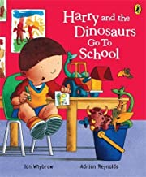

Harry and the dinosaurs go to school
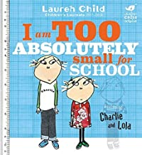
– by Ian Whybrow and Adrian Reynolds

I am too absolutely small for school (Charlie and Lola)
– by Lauren Child

Topsy and Tim start school – by Jean and Gareth Adamson

Come to school too, Blue kangaroo! – by Emma Chichester-Clark

Usborne first experiences: Going to school – by Anna Civardi and Stephen Cartwright

Max and Millie start school (Usborne) – by Felicity Brooks and Desideria Guicciardini

Never take a bear to school – by Mark Sperring and Britta Teckentrup
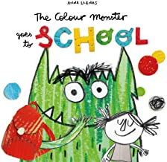
The colour monster goes to school – by Anna Llenas

The Koala who could – by Rachel Bright
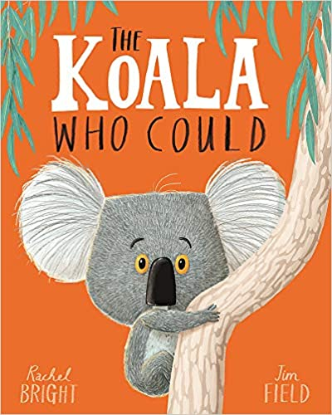
(This lovely book is about dealing with worry and change)

