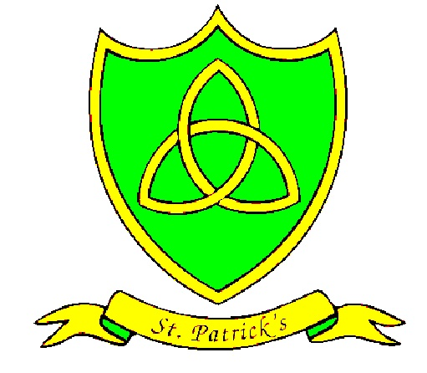
Year 1
Summer Curriculum Map

Subject | What we will learn | Resources, trips and visitors
English | This term we will start by reading Paper Planes by Jim Helmore which is a Promise Narrative, our writing focus is to write messages to each other.  Then we will be reading The Last Wolf by Mini Grey which is a Hunting Narrative. Our writing focus for this topic will be to write different recipes.  For more information please see Y1 English milestones http://stpatricksliverpool.co.uk/wp-content/uploads/2017/12/Reading-end-of-year-milestones.pdf  http://stpatricksliverpool.co.uk/wp-content/uploads/2017/12/Writing-end-of-year-milestones.pdf | Ideas for the weekend: write messages to your friends and family, post them on your daily walk or on Twitter.  Help to write recipes for your favourite meals.  Trips:  Resources:  Access to our library  Bug Club
Maths | Our work this term will focus largely on measuring. We will be using scales to find items that are heavy and light, seeing which containers have the most and least capacity and using different items to measure length. We will also learning about the days of the week, months of the year and sequencing our days. This will help us a lot when we learn to tell the time by the hour and half past the hour.  For more information please see Y1 Maths milestones  http://stpatricksliverpool.co.uk/wp-content/uploads/2017/12/Maths-end-of-year-milestones-.pdf | Ideas for the weekend:  Pairing items such as socks!  Sharing different treats, like sweets!  Measuring equipment ( length and capacity), baking or cooking.
Science | Our topic in science this term is plants.  We will be looking closely at the structure of trees. We will carry out observational drawings, labelling different parts of a tree.  We will be identifying and comparing deciduous and coniferous trees and thinking about seasonal changes.  We will plant seeds and bulbs making observations about their life cycle.  We will identify different parts of a flower.  We will identify some common plants and flowers.  We will observe changes in a bean plant making a record over time.  comparing For more information please see Y1 Science milestones  http://stpatricksliverpool.co.uk/wp-content/uploads/2017/12/Science-end-of-year-milestones-.pdf | Ideas for the weekend:  Visits to the park to look at plants and trees. Plant seeds or bulbs in pots or containers. Record what happens over time. Trips:  Resources:  Seeds, bulbs, books about plants and trees.
RE | Our final three topics include ‘Holidays and holy days, followed by ‘Being Sorry’ and ‘Neighbour’s’.  We will explore how new life can positively impact lives, and how different networks of friendships and relationships enable human beings to live together. | Ideas for the weekend: Visit mass at your local church  Trips:  Resources:  Bible stories
History/Geography | In History, we are going to be learning about seaside holidays. We will use different resources to find out about holidays in the past comparing them to holidays today. We will use different sources of information including photographs, pictures and written information to gain knowledge and make conclusions. We will create a timeline to sequence key changes, looking closely at clothes and beach toys and acivities. To find out more information please see Y1 History milestones  http://stpatricksliverpool.co.uk/wp-content/uploads/2017/12/History-end-of-year-milestones-.pdf  n | Ideas for the weekend:  Talk about experiences of visiting a beach.  Locate coastal areas around Liverpool on a map.  Trips:  Resources:  Information Books from the library
Art/DT | This term our Art we will be making animal models. We will look at different materials we could use and which ones will be the best to create different textures on different animals.  For more information please see Y1 Art milestones  http://stpatricksliverpool.co.uk/wp-content/uploads/2017/12/Art-end-of-year-milestones.pdf | Ideas for the weekend:  Try using different materials at home to make your own animal sculptures you could use play dough, cover your sculpture in other things you can find such as feathers, leaves, sand or try using different tools to create different textures. Trips:  Resources:  Play dough, salt dough, sand, leaves, feathers etc
Computing | For more information please see Y1 Computing milestones
PE | Year 1 are going to be doing athletics with Miss Edwards. We will develop our skills and confidence in running, jumping and throwing.  With Liam we will be playing tennis and cricket.  For more information please see Y1 PE milestones  http://stpatricksliverpool.co.uk/wp-content/uploads/2017/12/PE-end-of-year-milestones.pdf | Ideas for the weekend:  Organise a family sports day practicing different athletic sports such at relay and hurdles with your child. Play a game of cricket or tennis in the back garden or local park.  Trips:  Resources:  PE kits every Tuesday
Music | For more information please see Y1 Music milestones  http://stpatricksliverpool.co.uk/wp-content/uploads/2017/12/Music-end-of-year-milestones-.pdf | Ideas for the weekend: Let your child perform songs they are learning in school for you and your family.  Trips: Any musicals or performances in the Philharmonic  Resources:
PSHE | The whole school themes for this term are: ‘Relationships’ and ‘Changes’.  These will link quite closely to our RE topics therefore they will be a continuous theme in our discussions and class work. | Ideas for the weekend: Talk with your children about these topics.  Trips:  Resources:
Spanish | The children have a busy term learning how to say numbers 0-80, days of the week, fruits, food and colours. Then, numbers 0-100, family, habitats, body parts.  For more information please see Y1 Spanish milestones  http://stpatricksliverpool.co.uk/wp-content/uploads/2017/12/Spanish-end-of-year-milestones-.pdf | Ideas for the weekend:  Visit a Spanish restaurant and practice saying hello, thank you, goodbye and other phrases they have learnt in Spanish.  La Tasca Address: 4 Queen Square, Liverpool L1 1RH  Or  Esteban Mediterranean Tapas Address: 40 Lark Ln, Liverpool L17 8UU  Trips:  Resources:

* Not all subjects are taught in every term

