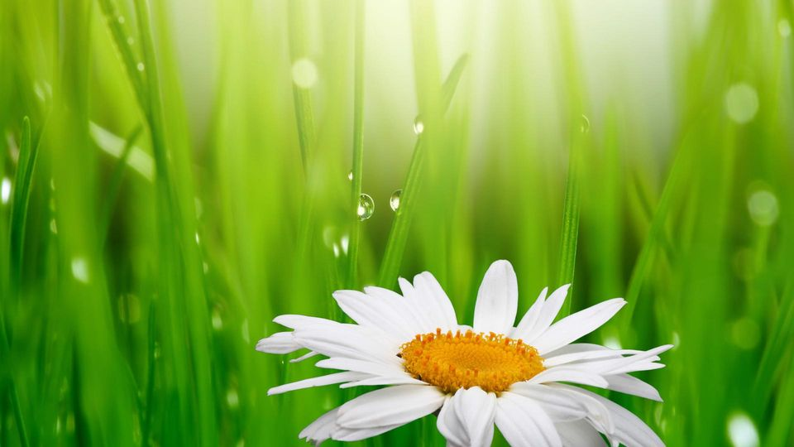

**Year 6 learners will…**

**Will have high aspirations.**

**Will have knowledge of vocations and careers.**

**Will be global citizens.**

**Will take risks.**

**Will be self motivating.**

**Will be successful**

**Will be accepting**

**Will hear and speak a foreign language.**

**Will have good manners & patience.**

**Will understand cause**

**and effect**

**To budget**

**Be emotionally intelligent.**

**Have a good standard of spoken English.**

**Will use scientific equipment/ carry out testing to a high standard.**

**Will show resilience,**

**tolerance & understand diversity.**

**Will be able to communicate**

**confidently.**

**Will be confident.**

**Go on a residential abroad.**

**Will have a positive, diligent attitude.**

**Will take part in outdoor learning.**

**Be leaders**

**Read a map**

**Play a music instrument**

**Grow & cook own food**

Go on a hill walk and through the countryside

**Will understand the importance of learning and how mistakes are learning experiences.**

**Will be proud**

**To be passionate about learning.**

**Will understand how to live a healthy lifestyle**

**Will be able to read, write**

**& use money carefully**

**Will know how to keep themselves safe and what to do if they feel unsafe. PANTS, Esafety.**

**Will take part in competition.**