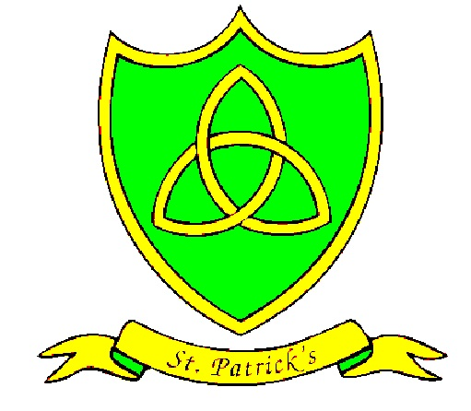
Year 6
Summer Curriculum Map

Subject | What we will learn | Resources, trips and visitors
English | Books-  Rooftoppers by .Katherine Rundell This book merges fantasy and historical fiction with sophisticated lyrical prose and vivid imagery. We will use the book as a stimulus for our focus on explanation writing  Macbeth . Overall aims of this teaching sequence are to explore the themes of a Shakespeare tragedy and the complex relationships within the story. We will also look at the prose and begin to understand the language of Shakespeare.  SPAG –  - Determiners  - Passive voice  - Subjunctive form  - Parts of Speech  - Formal language | - Books  - London visit  - Visits from Shakespeare actor  - Theatre visit.  - Maps atlases  - Museum visit  - Bug club
Maths | Statistics: Children will interpret and construct pie charts and line graphs and use these to solve problems. This will connect to their work on angles, fractions and percentages.  Pupils both read and draw graphs relating two variables and connect conversion from  kilometres to miles in measurement to  its graphical representation.  Children will learn when it is appropriate to  find the mean of a data set. | http://www.bbc.co.uk/education/subjects/z826n39  - Doodle maths  - See school website  - Parent coffee mornings
Science | Human Health and Fitness  Identify that animals, including humans, need the right types and amount of nutrition, and that they cannot make their own food; they get nutrition from what they eat.  Identify that humans and some other animals have skeletons and muscles for support, protection and movement.  Describe the simple functions of the basic parts of the digestive system in humans.  Identify the different types of teeth in humans and their simple functions.  Identify and name the main parts of the human circulatory system, and describe the functions of the heart, blood vessels and blood.  Recognise the impact of diet, exercise, drugs and lifestyle on the way their bodies function.  Describe the ways in which nutrients and water are transported within animals, including humans.  Skills focus: Interpreting Data. | Activity week ( Watersports, trampolining, hill walking and ski-ing)  Kick off Kilometre  bit.ly/body-home-workout  bit.ly/primary-eatwell-guide  bit.ly/sports-science  bit.ly/sports-timeline  bit.ly/international-council
Geography | North America  We will identify the 23 countries of North America, from the vast lands of the USA and Canada down through Central America and on to the Caribbean islands. On the way we will explore the various geographical features of different areas of North America and compare them with our own locality. | Maps  Atlases  Google Earth
Art | Printing. Pop Art  Children will recognise how printed pattern has been used historically and culturally in different ways and different purposes  Children will design a pattern for a printing block and use digital cameras and computer software to record ideas | Andy Warhol  Big Art –Walker Art Gallery  Days out sketching building our art skills.

