Autumn Term Curriculum Overview 2016
Maths
- Read, write, order and compare number to at least 1 000 000 and determine to value of each digit.
- Interpret negative numbers in context.
- Rounding any number up to 6 digits.
- Read Roman numerals to 1000.
- Addition and subtraction of whole numbers with more than 4 digits.
- Add and subtract larger numbers mentally.
- Solve number and practical problems.
- Solve addition and subtraction multi-step problems and use rounding to check.
English
Our first class novel will be The London Eye Mystery. Children will be focusing of the genres of report and diary writing.

After half term, we will be focusing on narrative and instruction writing with the text Stay Where You Are and Then Leave, before looking at film narrative with the animation The Piano.
Art/DT
In art, we will begin by studying nature sculptures and looking closely at the work by artist Andy Goldsworthy. We will be using nature and natural materials to create our own end sculpture.

In DT we will be designing and creating our own embroidered Christmas themed bookmark.

Science
Our first science topic this year is Energy and Sound. We will be looking at the different types of energy – thermal, light, sound, potential, electrical and kinetic.
We have got some very exciting investigation planned and children will be responsible for organising and planning these.
History/Geography
Our first history topic is Vikings vs. Anglo Saxons. We will begin by exploring how England became England and what life was like before and during the Viking invasions.

In geography we will be looking closely at The United Kingdom. We will identify and describe geographical features, towns, cities, rivers and mountains in our country.
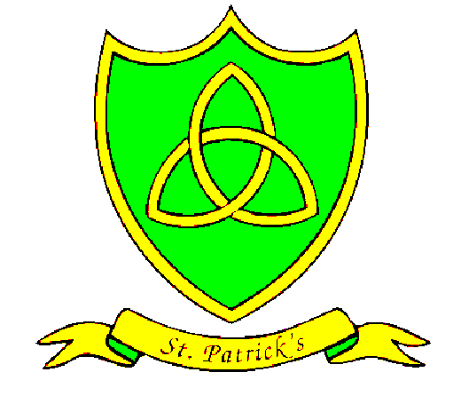
English Basic Skills

- Relative clauses and relative pronouns
- Showing degrees of possibility using adverbs and model verbs
- Using brackets, dashes and commas confidently
- Link ideas across paragraphs

RE
Our first three topics this year will be:
- Domestic Church - Family - Ourselves
- Baptism/Confirmation - Belonging - Life Choices
- Advent/Christmas - Loving - Hope
Maths Basic Skills

- Times table practice and skills
- Recall of number facts
- Mental maths skills
- Reading, writing and ordering numbers
- Rounding
- Addition, subtraction, multiplication and divsion using column method

Spanish
This term, we will be learning:
- Reinforcement of what was learnt in year 4
- Numbers to 1000
- Personal information
- 3rd person
- Nationalities - masculine and feminine,
- ID card/passport
- Weather expressions and compass directions
SEAL/PSHE
Our PSHE topics will be covered in the second half of the autumn term. We will begin by focusing on Remembrance Day and the themes of death and Grief.

After that, our theme is ‘Come and Join the Celebration’ where we will look at the different cultures in our community.
PE
With Miss Waters, Year 5 will be doing gymnastics and dance this half term.

Children will also be learning to play tag rugby and badminton with Mr. Hignett.

