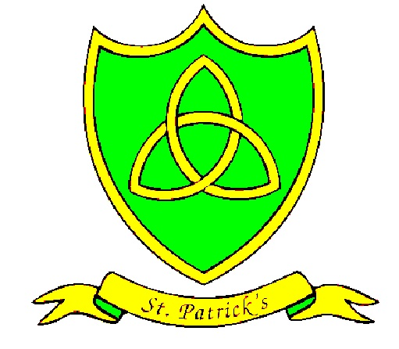
Year 4
Spring Curriculum Map

Subject | What we will learn | Resources, trips and visitors
English | We are going to be completing Gregory Cool and also reading Mouse Bird Snake Wolf by David Almond this half term. In these books we are going to be writing descriptively, kennings, persuasively, in role as characters and play scripts. | - Gregory Cool and Mouse Bird Snake Wolf books
Maths | We are going to be focusing on Measure and Geometry. We will be learning how to convert different units of measure in weight, length and capacity. In Geometry we will also be learning more about properties of 2-D shapes and plotting coordinates on a grid. | - Measuring equipment (mass, length, capacity)  - 2D and 3D shapes
RE | We have three topics to cover before the end of spring. We will be learning about our community and how the church plays a vital role in it.  Giving and Receiving is our second topic and  our final topic is called Self-Discipline. We will explore how carrying out lent from Ash Wednesday involves great self-discipline. | - Ash Wednesday Service  - St. Patrick’s day celebrations and service
PE | This term is about developing our strength, balance and flexibility in gymnastics with Mr Lowry. We will learn new skills such as backward rolls, shoulder stands and full turns using different equipment. | - Vault & spring board  - Mats  - Benches  - Hoops
Science | Spring term is all about chemistry in Science. We are going to be expanding our knowledge on chemical reactions. We’ll investigate things such as the hydrogel in nappies and electroplating. | - Empiribox resources  - External visitors e.g. Doctors, dentists.  - Catalyst Museum
History / Geography | In History we are moving on to the Mayans period. We’ll look at the development of the civilisation, the gods they worshipped and how it declined again.  Our Geography topic is called ‘Earning a Living’. We will be looking at how different people earn a living all over the world and how this can impact our day-to-day lives. | - Mayans books  - IPads  - Writing carving (soap)
Art / Design and Technology | In Art we are going to link it to our History topic, the Mayans. We will design and make our own Mayan shields using ModRoc.  We are going to complete a STEM project on pneumatics for DT. We will be designing a pneumatics product that is based on the Mayans. | - Cutting, shaping, measuring resources  - Parent learning afternoon  - ModRoc
Spanish | The children will be learning the names of farm animals and the sounds ‘c’ and ‘k’ in Spanish for the spring term. | - Spanish teacher
Music | In Music we are going to be continuing to improve on our flute playing skills. We did fantastically well with our Christmas performance and we aim to play more difficult tunes by the end of Spring. | - Music teacher  - Flute  - Charanga (website)

