Autumn Term Curriculum Overview 2016
Maths

Our work this term will focus largely on number and the number system. The children will be focus on various methods of calculation, practicing their counting skills and consolidating their knowledge of place value.
Art/DT

We will be doing Art this term. We will be studying the artist Ben Johnson and investigating his cityscape work. We will be going to the Museum to get a closer look at his cityscape of Liverpool.
Science

We will be doing lots of exciting experiments to learn all about energy Within this unit, we will be developing our scientific knowledge of how and where energy is produced.
English

We start the year with the Moon Man.

Throughout the unit we are going to be developing our writing skills throughout poetry, recounts, persuasive letters and newspapers. We will also get the opportunity to do role play and drama with the chosen text.
English Basic Skills

List sentences e.g. It was a dark, cold, misty night on the moon.
Doubly –ly e.g. The Moon Man shouted loudly and fiercly.
All the Ws e.g. Would the Moon Man arrive safely on earth? What if the Moon Man is not accepted on earth?
2Ad: He was a strange, white creature with a huge, circular head.
Simile: The fiery comet flew through the air like an eagle.
Short: The comet crashed! He was sore.

History/Geography

In History, we are going to explore the Early Civilisations. We will be finding lots out about how different civilisations traded, developed writing systems and settled in different parts of the world.

Our Geography focus this term is on Europe. We will be exploring maps to find out more about different countries and their traditions.
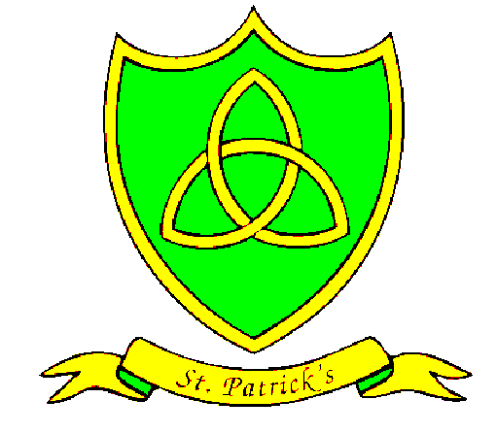
RE

Our year begins with ‘People’, followed by ‘Called’ where the children learn more about sharing their life through Baptism and Confirmation.
Islam will be our other faith this term and we will spend a week studying the Qur’an. Our final topic before Christmas our topic is ‘Advent’.
Maths Basic Skills

Practicing our 6, 7 and 9 times tables.
Knowing the value of each digit in a 4-digit number.
Add a series of 2-digit numbers.
Subtract a series of 2-digit numbers.
Add 10 and 100 to 4-digit numbers
Subtract 10 and 100 from 4-digit numbers.
Read and write numbers up to 1000.
Spanish

The children will be very busy in term one learning greetings, personal information, feelings and emotions, classroom language, numbers seasons, countries and dates.
In the second half of the term, they will also learn the key sounds in the alphabet, time, animals and habitats.

SEAL/PSHE

The whole school themes for this term are: ‘New Beginnings’, ‘Getting On And Falling Out’ and ‘Say No To Bullying’.
In class we will explore how to control our emotions when we are in new and difficult situations. We will also think about how to treat our peers. Additionally, we will discuss how to act and behave if we have not treated someone with kindness and respect.
PE

Class 4 are developing their football skills with Mr Hignet this term.

We will also be going swimming with Mr Lowry.

