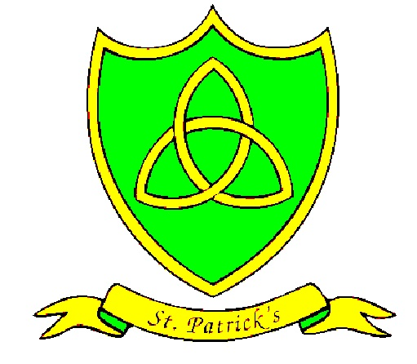
Year 3
Spring Curriculum Map

Subject | What we will learn | Resources, trips and visitors
English | We start the new year with a book called ‘African Tales’. This will help the children to develop their writing of non-fiction while learning about different cultures.  After Easter, we read a beautiful book called ‘Jemmy Button’. We focus on genres such as poetry and diary entries and discuss issues such as immigration and human rights. | Our class library will be supplemented with a range of fiction and non-fiction books about Africa. Children with African heritage will be encouraged to bring in objects from home to share with other children.
Maths | Our work this term will focus largely on fractions, measure and shape. We will do lots of practical problem solving and reasoning to enhance our understanding of length, volume, mass and money.  In Spring 2, we get to explore the properties of 2D and 3D shapes and use our understanding of angles as a measure of turn to go on Easter Treasure Hunts! | A km walk around our local area.
Science | Our exciting Science topic this term is Chemical Changes! Get you lab coats ready and prepare for some exciting experiments!  Our skills focus for this term is conducting experiments and gathering and interpreting data. | We will go on a class trip to the Catalyst Museum in Widnes where we will learn to use data loggers.
Art | Our art this term has strong links with computing as the children will be photographing and manipulating images to create digital collages. | The children will focus their images on the natural world so expect to see us around the school grounds taking snaps!
DT | In DT, we will be tasting, evaluation, designing and making our own healthy snacks – houmous! | We want to use as much of our own produce as possible in our houmous. The children will be working with Mrs Rogers to harvest their own herbs for their recipes.
History | In History, we are travelling back in time to the Roman era! We will be learning about battles with the Celts and Boudicca’s Army! | Our class library will be supplemented with a range of books about the Roman era.
Geography | Our Geography studies this term are about international farming. We will be learning about different climates and what food is produced there. It will be interesting to investigate just how far our breakfast travels to get to us! | We will be visiting a local fruit farm to see how food is grown in the UK.
PE | In Spring one, we are learning street tap! Later, Year 3 are practicing netball with Mr Hignett. Swimming will be every Friday afternoon. | Steble Street Baths
RE | The new year begins with ‘Journeys’, followed by ‘Listening and Sharing’ and finally ‘Giving All’.  During Holy Week, we will be part of the Easter service and will tell the story of Jesus entering Jerusalem on the back of a donkey. | St Patrick’s Church
PSHE | All of this term we will be learning about healthy lifestyles. This encompasses the principals of a healthy diet, healthy minds and the importance of exercise.
Spanish | The children have a busy term learning how to count and how to say the days of the week and months of the year in Spanish.  They will be doing some written work about themselves. As well as learning how to say the names of animals in Spanish.

