Autumn Term Curriculum Overview 2016

Maths

Our work this term will focus largely on number and the number system. The children will be learning more efficient methods of calculation, practicing their counting skills and extending their knowledge of place value.

Art/DT

This term we have an art focus. We will be studying the artist Henri Matisse and investigating his light and dark patterns. The children will be recreating their own patterns using paper cutting.

Science

Energy and Sound is our focus for autumn term. The children will be developing their skills of making predictions and planning investigations.

Through practical exploration, they will learn about forms of energy such as light, heat, kinetics and sound!

English

We have a fantastic non-fiction text to base our English learning around this term, ‘The pebble in my pocket’. Beautiful illustrations bring the words to life. There are lots of Science and history links for the children to explore.

After half term we will be reading ‘Ug Boy Genius’, this will enrich our learning about the Stone Age and help is with letter writing.

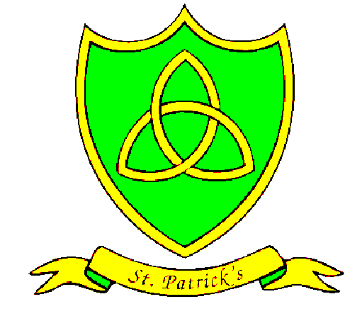

English Basic Skills

Adverbs e.g. slowly, gently, rapidly

Adverbial openers e.g. ‘Breathing in the sweet scent of summer, the girl ran through the grass.’

Varying the noun e.g. dragon-beast-reptile

Proper nouns e.g Liverpool

Questions

Inverted commas for speech

RE

Our year begins with ‘Homes’, followed by ‘Promises’ where the children explore the promises made at baptism.

After half term, we spend a week studying the places special to Islam. In the time leading up to Christmas, our topic is visitors. We will think about those who visited the baby Jesus and what this tells us about God.

Maths Basic Skills

Practicing our 2, 3 and 4 times tables.

Knowing the value of each digit in a 3-digit number.

Add a series of 1-digit numbers.

Subtract a series of 1-digit numbers.

Add 10 and 100to a 3-digit number.

Subtract 10 and 100 from a 3-digit number.

Count in multiples of 4 and 8.

Read and write numbers up to 1000.

Spanish

The children have a busy term learning how to count and how to say the days of the week and months of the year in Spanish.

They will be doing some written work about themselves. As well as learning how to say the names of animals in Spanish.

PSHE

E-Safety is hugely important for children of all ages. We will spend the first half term looking in detail at how we can keep safe online and when using electronic devices.

After half term, we will think about issues surrounding loss and separation before learning about how to use money sensibly.

.

PE

Year 3 are practicing agility and football with Mr Hignett and gymnastics and dance with Miss Jones.

History/Geography

In History, we are travelling back in time to the Stone Age! Investigating monuments such as Stonehenge and looking at prehistoric cave carvings.

Our Geography studies center around map work and looking in detail at the continents and countries of the world.