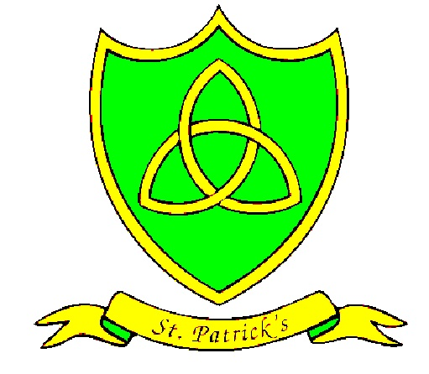
Year 2
Summer Curriculum Map

Subject | What we will learn | Resources, trips and visitors
English | In the summer term, we will continue to read “Lila and the Secret of Rain”. We will use this book to develop our ability to write narratives based on a known text.  We will also focus on “The Magic Finger” by Roald Dahl and use the book to inspire us to write persuasive letters!  In our English basic skills, we will be:  Writing sentences with different forms: statement, question, exclamation, command.  Using expanded noun phrases for description and specification [for example, the blue butterfly, plain flour, the man in the moon, etc.].  Using the present and past tenses correctly and consistently including the progressive form [e.g. I am writing, I was running, etc.].  Using some of the diagonal and horizontal strokes needed to join letters when writing. | Trip to Storybarn at Calderstones Park
Maths | Interpret and construct simple pictograms, tally charts, block diagrams and simple tables  Ask and answer simple questions by counting the number of objects in each category and sorting the categories by quantity  Ask and answer questions about totalling and comparing categorical data.  Revise:  Find different combinations of coins that equal the same amounts of money.  Recognise, name and write fractions $\frac{1}{ 3}$ $\frac{1}{ 4}\frac{2}{ 4}\frac{3}{ 4}$of a length, shape, set of objects or quantity.  Add and subtract numbers using concrete objects, pictorial representations, and mentally, including:  • a two-digit number and ones  • a two-digit number and tens  • two two-digit numbers  • adding three one-digit numbers.  Recall and use multiplication and division facts for the 2, 5 and 10 multiplication tables, including recognising odd and even numbers.  Tell and write the time to five minutes, including quarter past/to the hour and draw the hands on a clock face to show these times.
Science | Toys (An Introduction to Physics)  Children will learn to:  Compare the whether a material is suitable for a job.  Identify whether a material is suitable for a job.  Know that solids can be malleable.  List a variety of uses for a given material e.g. metal – coins, spoons, cans, cars.  Explain why an object can be made from different material e.g. a spoon can be wooden or metal.  Children will also learn to work scientifically, by using scientific equipment, carrying out simple tests, gathering data and analysing results.
RE | Spread the Word  This topic: learning outcomes  Know and understand:  Passing on messages – Explore  Pentecost, spreading the Gospel message through the gift of the Holy Spirit – Reveal  Acquire the skills of assimilation celebration and application of the above – Respond  Rules  This topic: learning outcomes  Know and understand:  How rules can help at home and in school – Explore  The reasons for rules in the Christian family – Reveal  Acquire the skills of assimilation, celebration and application of the above – Respond  Treasures  This Topic: learning outcomes  Know and understand:  What we treasure – Explore  The world is God’s treasure given to us – Reveal  Acquire the skills of assimilation celebration and application of the above – Respond
Spanish | We are going to practise saying numbers 0-100. We will learn to talk about feelings, animals including sea animals and their habitats, the sea side, fruits and healthy eating. We will also be reading a Spanish version of “The Gruffalo” and talking about likes and dislikes using “me gusta/no me gusta”. Furthermore, we will learn to sing ♫”La sandía gorda” “Un pulpito” and “Una sardina” ♫.
History | Seaside Holidays in the Past  To identify features of a seaside holiday.  To find out when and how seaside holidays became popular.  To find out what seaside holidays were like 100 years ago.  To use photographs to find clues as to what seaside holidays were like in the past.
Geography | My World and Me  In this topic, we will:  To compare the land features and climate of the UK and Ecuador.  To compare the capital cities of the UK and Ecuador.  To find out where different animals live in the world.  To identify physical and human features in aerial photos.  To create a map with a key.
PE | Athletics  During this topic children will learn to:  Demonstrate the five basic jumps on their own, e.g. a series of hops, and in combination, e.g. hop, one-two, two-two, showing control at take-off and landing.  Run continuously for about one minute and, when required, show the difference between running at speed and jogging.  Throw with increasing accuracy and coordination into targets set at different distances.  Demonstrate a range of throwing actions using a variety of games equipment.  This term, the children will also develop their short tennis and cricket skills.
Art | Creating sand sculptures  To create sand sculptures by participating in sand sculpture workshops by Tom Bollard (Sand in Your Eye), developing carving skills to design 3D models, using different materials to carve, shave and shape wet sand. | Visit from Faith Bebbington – local artist.  Trip to Thurstaston
DT | Design a sail for a boat  During Design and Technology, children will I can design a functional sail for a boat based on design criteria. Children will learn how to use a range of tools for cutting, joining, shaping and finishing, and will evaluate their finished product.
SEAL/PSHE | This subject is related to the social and emotional aspects of learning (SEAL). This term, we are focusing on the themes of Relationships and Changes, which focus on developing children's skills in four key areas: empathy, self-awareness, social skills and motivation.
Music | During the summer topic “Round and Round”, children will listen to and appraise different styles of music including Latin bossa nova, film music, big band jazz, mash-up and Latin fusion. Children will identify different ways sounds can be made and changed, use and choose sounds confidently in response to a stimulus, recognise and control how sounds can be made louder, quieter, faster and slower. They will also choose sounds and instruments and suggest how they should be used and played.
ICT | In computing, Year 2 will be using iPads to programme Sphero robot toys so that they can move in a range of directions with control. We will also be using the Sonic Pics iPad app in our summer geography topic, and learning to use 2Publish as part of our maths curriculum.  In e-safety this term, we will focus on rating websites. Pupils will discuss criteria for rating informational websites and apply them to an assigned site. Pupils will learn that all websites are not equally good sources of information.

