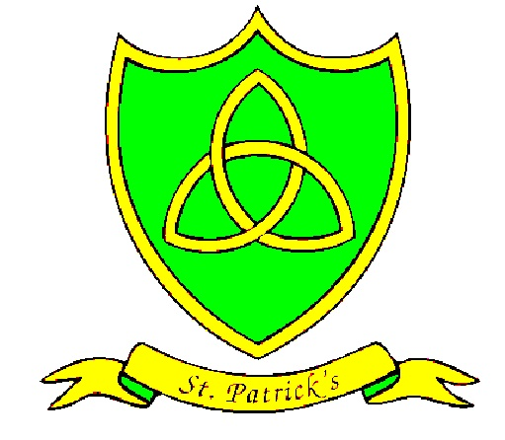
Year 2
Spring Curriculum Map

Subject | What we will learn | Resources, trips and visitors
English | In the spring term, we will be reading “One Night Far From Here”, using the text to help us to write diary entries.  Our next book will be “Lila and the Secret of Rain”. We will use this book to develop our ability to write narratives based on a known text.
Maths | Choose and use appropriate standard units to estimate and measure length/height (cm/m), mass (g/kg), capacity (l/ml) and temperature (°C).  Combine amounts of £ and p to make a particular value, and find different combinations of coins that equal the same amounts of money.  Identify and describe the properties of 2-D shapes, including the number of sides and line symmetry in a vertical line.  Identify and describe the properties of 3-D shapes, including the number of edges, vertices and faces.  Use mathematical vocabulary to describe position, direction and movement including distinguishing between rotation as a turn and in terms of right angles for quarter, half and three-quarter turns, and movement in a straight line.
Science | Plants and Trees (Observing)  Children will learn to:  - Describe what plants need to survive  - Observe and describe how seeds and bulbs grow into mature plants  - Find out & describe how plants need water, light and a suitable temperature to grow and stay healthy.  They will observe closely by using <see, touch, smell, hear or taste> to help them answer questions; using some scientific words to describe what they have seen and measured; and compare several things. | Eco councillors to Forest School session at John Moores University  Visit from Laura Howarth from Knowsley Safari Park
RE | Books  • Pupils will know and understand about the different books used at home and in school – Explore  • Pupils will know and understand the books used in Church on Sunday by the parish family – Reveal  Acquire the skills of assimilation, celebration and application of the above – Respond  Thanksgiving  This Topic: learning outcomes  • Pupils will know and understand different ways to say thank you – Explore  • Pupils will know and understand the Eucharist: the parish family thanks God for Jesus – Reveal  Acquire the skills of assimilation, celebration and application of the above – Respond  Opportunities  This Topic: learning outcomes  • Pupils will know and understand that each day offers opportunities for good – Explore  • Pupils will know and understand about Lent, the opportunity to turn towards what is good in preparation for Easter – Reveal  Acquire the skills of assimilation, celebration and application of the above – Respond
Spanish | We are going to practise saying numbers 0-100. We will learn to talk about days of the week and months of the year, using our vocabulary to say today’s date and when our birthdays are. We will be learning to say more body parts, singing ♫”Tengo dos ojos” and “La tía Mónica” ♫.  We will also be learning Spanish prepositions and reading the story “Un cuento muy oscuro”.
History | Florence Nightingale  In this topic, we will discover:  Who Florence Nightingale was and when she lived.  Why Florence Nightingale went to Scutari and what hospital conditions were like when she got there.  How Florence Nightingale improved the conditions at the Scutari hospital.  What Florence Nightingale’s later life was like.  Similarities and differences between medical care now and in Victorian times.
Geography | Let’s Go On Safari  In this topic, we will:  Locate Africa on a world map and identify the country of Kenya.  Explore the climate and weather of Kenya.  Explore the animals of Kenya.  Learn to use compass points to navigate around a map.  Investigate the landscapes of Kenya.  Find out about the people and culture of Kenya.  Identify similarities and differences between Kenya and the UK.
PE | Gymnastics  During this topic children will learn to perform a series of rolls, steps, balances and jumps.  Children will explore a variety of these movements and balances with coordination and control, creating their own sequences.  This term, the children will also develop their football and basketball skills. | Key Stage 1 gymnastic competition
Art | Self-portraits in the style of Picasso  Children will create self-portraits in the style of Picasso by:  representing shade and texture through close observation; using direct observation as a starting point for work; understanding abstract art; and using synthetic cubism techniques. | Visit to the Walker Art Gallery
DT | Design a meal for a special guest - Soup  During Design and Technology, children will design a meal for a special guest. They will learn how to make soup, using appropriate equipment and learning how to stay safe when cooking. | Pizza-making workshop with Tracey Mann
SEAL/PSHE | This subject is related to the social and emotional aspects of learning (SEAL). This term, we are focusing on the themes of Going for Goals and Good to be Me, which focus on developing children's skills in four key areas: empathy, self-awareness, social skills and motivation.
Music | Rap, sing and play with a sense of pulse and rhythm.  Perform songs: ‘Hey You!’, ‘Hands, Feet, Heart’ and ‘Drive’.  Use a glockenspiel and beater correctly, producing a good tone.  Learn note names D and E.  Follow basic notation.  Children will also learn how to appraise their own performance.  Following this, children will identify different ways sounds can be made and changed.  Use and choose sounds confidently in response to a stimulus.  Recognise and control how sounds can be made louder, quieter, faster and slower.  Choose sounds and instruments and suggest how they should be used and played.
ICT | In computing, Year 2 will be using PurpleMash 2DIY 3D to design their own maths quizzes. We will also be using Popplet and digital photography during other lessons.  In e-safety this term, we will focus on cyber bulling. We will also learn about key word searches, learning how to stay safe online when searching for information.
Maths Basic Skills | Recall and use multiplication and division facts for the 5 multiplication tables.  Calculate mathematical statements for multiplication and division within the multiplication tables and write them using the multiplication (x) division (÷) and equals (=) signs.  Recognise fractions: ½ ¼ ¾ and 1/3 and find those fractions of a shape, length, set of objects or quantity.
English Basic Skills | We will be:  Writing sentences with different forms: statement, question, exclamation, command.  Using expanded noun phrases for description and specification [for example, the blue butterfly, plain flour, the man in the moon, etc.].  Using the present and past tenses correctly and consistently including the progressive form [e.g. I am writing, I was running, etc.].  Starting to use some of the diagonal and horizontal strokes needed to join letters when writing.

