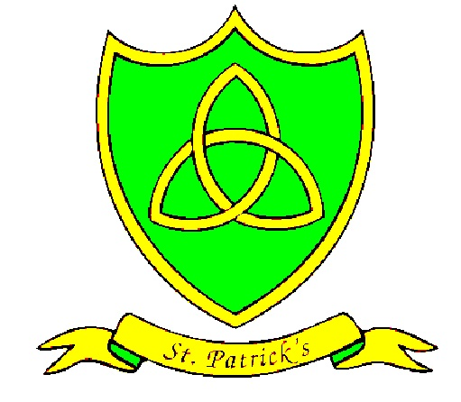
Year 1
Summer Curriculum Map

Subject | What we will learn | Resources, trips and visitors
English | This term we will start by reading The Dark by Lemony Snicket. We will be looking at lots of different features of writing including poems. | Trip to catalyst museum to study light and dark.  Trips to the local library  Access to our library  Bug Club
Maths | Our work this term will focus largely on measuring. We will be using scales to find items that are heavy and light, seeing which containers have the most and least capacity and using different items to measure length. We will also learning about the days of the week, months of the year and sequencing our days. This will help us a lot when we learn to tell the time by the hour and half past the hour. | Pairing items such as socks!  Sharing different treats, like sweets!  Measuring equipment ( length and capacity)
Science | This term our science topic will be looking at how toys work as an introduction to physics we will asking the children to ask simple questions and recognise that they can be answered in different ways  observe closely, using simple  equipment perform simple tests  gathering and recording data to help in  answering questions think about the properties of materials that make them suitable or unsuitable for particular purposes and they should be encouraged to think about unusual and creative uses for everyday materials find out about people who have developed useful new materials, for example John Dunlop, Charles Macintosh or John McAdam | Empiribox resources  External visitor with careers in science  Visits to the museum of Liverpool  And the catalyst museum.
RE | Our final three topics include ‘Holidays and holy days, followed by ‘Being Sorry’ and ‘Neighbour’s’.  We will explore how new life can positively impact lives, and how different networks of friendships and relationships enable human beings to live together. | Bible stories
History/Geography | In History, we are going to be learning about castle. Finding out about different castles in the UK and who lives there. We will learn about how castles where decorated using tapestries and other items. | Visits to castles such as Chester Castle.  Information Books from the library
Art/DT | This term our Art we will be making animal models. We will look at different materials we could use and which ones will be the best to create different textures. | Fruit  Kebab making equipment-skewers, knives, chopping boards etc.  Walks around our area to find natural/environmental objecs
PE | Year 1 are going to be doing athletics with Miss Sumner. We will develop our skills and confidence in running, jumping and throwing.  With Mr Hignet we will be playing tennis and cricket. | PE kits every Tuesday and Wednesday!!
PSHE | The whole school themes for this term are: ‘Relationships’ and ‘Changes’.  These will link quite closely to our RE topics therefore they will be a continuous theme in our discussions and class work.
Spanish | The children have a busy term learning how to say numbers 0-80, days of the week, fruits, food and colours. Then, numbers 0-100, family, habitats, body parts.

