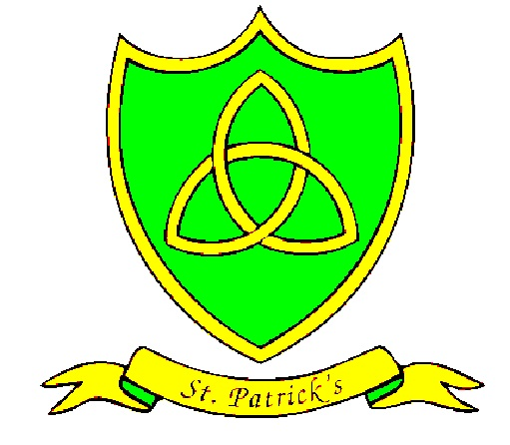
Year 5
Spring Curriculum Map

Subject | What we will learn | Resources, trips and visitors
English | We will begin this term with a book called Varmints. A beautifully illustrated book which allows us to reflect on the world we live in and the very real and philosophical challenges we face. Our genre focus will be journalistic writing and persuasion.  After half term, we will read Cosmic Disco. This book has a huge collection of inspiring poetry allowing the children to write their own choral and performance pieces. | Varmints  Cosmic Disco  Other examples of genres  Poetry books  Access to our library  Bug Club
Maths | Converting between units of measure  Metric and imperial units of measurement  Area and perimeter  Volume  Identifying 3D shapes from 2D representations  Irregular and regular polygons  Angles – acute, obtuse, reflex and right  Estimating and drawing accurate angles | Measuring equipment (mass, length and capacity)  2D and 3D shapes  Doodle Maths
Science | Our science topic this term is Chemical Changes.  Our skills focus for this term is conducting experiments and gathering and interpreting data. | Empiribox resources  External visitor with careers in science
RE | Our next three RE topics for this term are:  - Mission – Local Church - Community  - Memorial Sacrifice – Eucharist – Relating  - Sacrifice – Lent/Easter - Giving | Ash Wednesday and Easter services  St. Patrick’s Day celebrations and service
History | During our history lessons, we will be looking closely at the Shang Dynasty of Ancient China. We will be exploring evidence of the Shang Kings, finding out about royal burials and discovering what life was like for ordinary people. | iPad’s  Information books
Geography | In geography, we will be exploring the rivers of the world, before taking a closer look at one nearer to home. We will get to see the River Mersey and find out why it was so important for our city. | Exploring the River Mersey and our local Docks.  Digimaps  Atlases and maps
Art | Our art topic for this term will focus of the techniques of printing and collage whilst looking closely at the work of Vincent Van Gogh. Children will try many different mediums before joining to create a giant class masterpiece!  We will also be entering the Dot Art competition based on photography. | China Town walk to take our photographs.
DT | In DT, we will taste different types of bread to help us design and cook our own. | Absolute Catering will be helping us make our Soda Bread
PE | With Mr Hignett, the children will be taking part in basketball and volleyball lessons.  We also be going swimming every Friday afternoon. | Park Road swimming baths
Spanish | Numbers 1000  Family  Personal descriptions and descriptive words for hair and eyes  Colours  Clothes and Uniform  Money and Euros  Shopping  Time on hour/half
PSHE | We will be looking at ways to keep ourselves safe and healthy during our first half term. We will be looking at the topics of Drugs, Alcohol and Food Choices.  During spring two we will focus on our own confidence, listening skills and how we respond to different scenarios. | Barnadoes Life Skills sessions for 10 weeks.  Trip to Maritime Museum to look at staying healthy and the effects of drugs.

