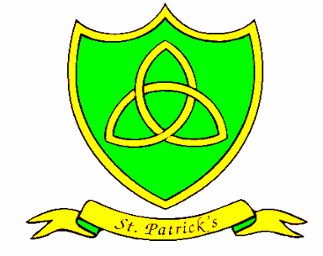
St. Patrick’s Catholic Primary School
Peace, Love and Understanding

Upper Hill Street
Liverpool
L8 5UX

Tel: 0151 709 1062
Fax: 0151 707 9367
Head Teacher: Mrs. J Lewis website:http://stpatricksliverpool.co.uk
Twitter: @St_patricks
14th September 2016
Dear Parents/Carers,

I informed you last week of the damage to our hall floor, and the disruption to lunchtimes. The work has been agreed by the insurers, and will start tomorrow, Thursday 15th September. There will be some disruption to the way the Y4 children come in to school. The children in Year 4 will need to go in through the fire doors outside their classroom.
Please bear with us during this difficult time. We are doing our best to make sure that the children have the minimum disruption.

Could I ask that parents and carers are vigilant in making sure that the gates are closed behind you? This is extremely important in keeping our children safe and I would be very grateful if you could do this.

Finally, I would like to invite all parents and carers to our coffee morning this Friday, which will take place after the assembly. We will be talking about our behaviour policy and the systems and procedures we follow.

If you have any queries, then please contact us, and we will do everything we can to help.

Thank you,

J. Lewis










